JMC & ONWA WAYPOINT SYMBOL

**SHAPE:**

**COLOR:**

Red

Green

Yellow

Blue

Pink

Cyan

White

( Please review the attachment for details )

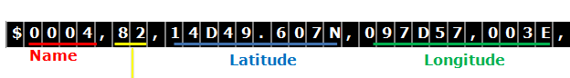

|  |  |  |
| --- | --- | --- |
| Value | Symbol | Color |
| 0x82 |  | red |
| 0x84 | -- | green |
| 0x86 | -- | yellow |
| 0x88 | -- | black |
| 0x8a | -- | cyan |
| 0x8c | -- | blue |
| 0x8e | -- | while |
| 0x92 |  | red |
| ----- | ----- | ----- |
| 0x9e | -- | while |
| 0xa2 |  | red |
| 0xb2 |  | red |
| 0xc2 |  | red |
| 0xd2 |  | red |
| 0xe2 |  | red |
| 0xf2 |  | red |
|  |  |  |